**Title: ALGORITHMIC TRADING**

**Mentee: Ajay Kumar Gupta, Birla Institute of Technology, Mesra**

**Mentor: Anindya Goswami, and Ayan Mahalanobis, IISER Pune**

**ABSTRACT-** For financial time series data analysis, support and resistance are very popular concepts among traders. These help a trader to anticipate quantitatively the price movements in near future. The support and resistance are represented by straight lines. This report, after a brief introduction to support and resistance, presents an algorithm to find those. An example has also been shown to illustrate it.

**SUPPORT-** A support level is a level where the price tends to find support as it falls. The traders belief that the price is more likely to bounce off this level rather than break through it. At this price level demand is thought to be strong enough to prevent the price declining further. However, once the price breaches this level, by an amount exceeding some noise, traders re define a new support from the recent lag data.

**RESISTANCE-** A resistance level is the opposite of a support level. It is where the price tends to find resistance as it rises. Again, this means that the price is more likely to bounce off this level rather than break through it. At this price level selling is thought to be strong enough to prevent the price from rising further. However, once the price has breached this level, by an amount exceeding some noise, it is likely to continue rising until meeting another resistance level.

**IMPORTANCE OF SUPPORT AND RESISTANCE LEVEL-** These levels, if found act as hypothetical barriers, preventing the price of an asset from getting pushed in a certain direction in near future. These levels can act as trend reversal due to alteration in demand and supply. Once an area or zone of support and resistance is identified, it provides valuable points to trade entry and exit points.

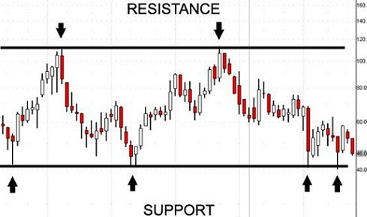

Figure 1, Support and Resistance; image source-Wikipedia.

**OBJECTIVE:**

Suppose that we have a time series data {S(t), t=1,2, ..., n}. Given l unit of lag and present time t, we intend to find out the equations of the support and resistance line based on the l units of lag data. At the first stage, we wish to plot the above lines to achieve a graphical visualization. At the second stage, our goal is to find out an empirical distribution of δ+(l) and δ-(l), the length of time intervals in immediate future when the time series data obeyed the resistance and support respectively for every given l. At the third stage, we would find the conditional distributions of δ+(l) and δ-(l), given the present price S(t). At the fourth stage we would build an algorithm which checks whether these conditional distributions obtained from a training data can perform well with some test data. At the fifth stage we would consider various different types of financial time series including, equities, indices, and exchange rates etc and use our algorithm to check if the above support-resistance analysis has any significant predictive power for any such types of data. Furthermore, we would ask, if there is some significant predictive power, what is the length of near future, where the predictions are reliable?

The algorithm of the first stage is given below.

**ALGORITHM AND CODE**

import numpy as np

import pandas as pd

import matplotlib.pyplot as plt

#Given l and time t, find out the support and resistance by finding out the time points, through which the lines should pass.

#col is the input vector of time series.

# The output is a vector m[0,1,2,3,4,5] where m[1] and m[2] are the time points so that the support line is obtained by joining

# (m[1],col[m[1]]) and (m[2], col[m[2]]).

# m[0] gives the distance of CG from the support line.

# Similarly m[3] gives the distance of CG from the resistance line and m[4],m[5] give the resistance line.

col=[9835.4, 9837.65, 9847, 9839.3, 9834.1, 9825.6, 9822.7, 9814.35, 9811.65, 9806.95, 9821.1, 9822.4, 9816.95, 9810.05, 9808.6, 9809.2, 9797.35, 9786.25, 9787.15, 9793.9, 9801.75, 9803.5, 9804.45, 9800, 9802.4, 9806.3, 9802.25, 9807.05, 9809, 9807.65, 9802.95, 9798.6, 9796.95, 9797.4, 9798.3, 9793.95, 9796.7, 9799.15, 9804.8, 9810.1, 9800.9, 9794.95, 9794.3, 9790.35, 9792.9, 9785, 9790.05, 9790.8, 9790.95, 9793.65, 9792.7, 9796.05, 9796.45, 9792.35, 9786.8, 9782.45, 9791.7, 9789.3, 9793.65, 9797.45, 9790, 9794.15, 9796.05, 9793.1, 9779.5, 9777.35, 9775, 9764.25, 9768.35, 9773.8, 9773.85, 9765.8, 9765.5, 9761.05, 9768.35, 9767.75, 9783.65, 9809.05, 9803.75, 9805.3, 9807.7, 9805.7, 9803.6, 9814.75, 9848.5, 9851.65, 9844.5, 9841.95, 9842.05, 9835.25, 9847.5, 9839.6, 9836.5, 9828.6, 9832.2, 9838.25, 9828.75, 9829.05, 9821.3, 9816.05]

t=80

l=65

if l*0.5-(l/2)<>0:

l=l-1

cond1=[[0 for x in range(l)] for y in range(l)]

cond2=[[0 for x in range(l)] for y in range(l)]

J=[[0 for x in range(l)] for y in range(l)]

m=[0 for x in range(4)]

x=list(col[t-l:t])

g=[t-0.5*l,sum(x)/l]

m[0]=10**8

m[2]=10**8

for i in range(0,l/2):

for j in range(l/2,l):

a=np.abs((x[i]-x[j])*g[0]-(i-j)*g[1]+ (x[j]*i-x[i]*j))

b=np.sqrt((x[i]-x[j])**2+(i-j)**2)

J[i][j]=a/b

C= (x[i]-x[j])/(i-j)

for k in range (0,l):

if x[k]< x[j]+C*(k-j):

cond1[i][j]+=1

elif x[k]== x[j]+C*(k-j):

cond2[i][j]+=1

if cond1[i][j]==0:

m[0]=min(m[0],J[i][j])

m[1:2]=[i,j]

elif cond1[i][j]+cond2[i][j]==l:

m[3]=min(m[3],J[i][j])

if m[3]==J[i][j]:

m[4:5]=[i,j]

m[1]+=t-l

m[2]+=t-l

m[4]+=t-l

m[5]+=t-l

print "m=",m

#to print the time series graph with line of support and resistance in continuation with above code

print len(col)  
x=[]  
for i in range (1,101):  
 x.append(i)  
plt.scatter(x, col, label = 'Scatterplot', color = 'k', s = 10)  
plt.xlabel('x')  
plt.ylabel('y')  
plt.title('Interesting Graph')  
#plt.show()  
#Rounding off m to the nearest integerar = np.array(m)  
ar = np.round(ar,decimals = 0)  
ar = ar.astype(np.int) *#Converts float into int*print ar  
x1, y1 = [ar[1],ar[2]],[col[ar[1]],col[ar[2]]]  
x2, y2 = [ar[4],ar[5]],[col[ar[4]],col[ar[5]]]  
print x1,y1,x2,y2  
plt.plot(x1,y1,x2,y2,marker = 'o')  
plt.show()

**RESULT**

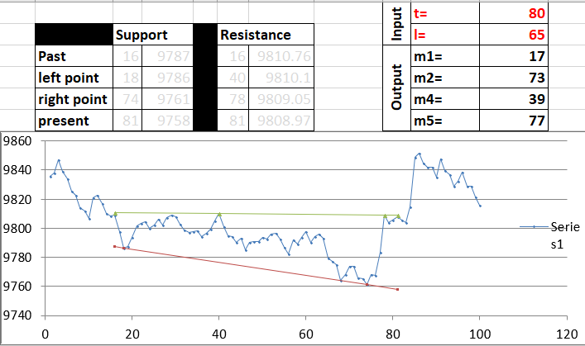

Figure 2 support and resistance line